Web Technologies

Task 7

(BSCS)

By
Sr | Name | Roll.  Number | Section
1 | Naeem Saleem | Fa-2023-Bscs-250 | G

Supervised by:

Mr. Muhammad yosaf



🛠️ Lab 7: Responsive Design with Flexbox & Bootstrap Guide
This lab requires you to upgrade a static HTML layout into a modern, responsive design using three powerful tools: Flexbox, Media Queries, and Bootstrap.

Task 1: Convert a Static Layout to a Flexbox Layout
You will apply display: flex; to the main container to manage the positioning of the header, content, sidebar, and footer.

Conceptual HTML Structure
HTML
<body>
<header>...</header>
<div class="main-container">
<main class="content">...</main>
<aside class="sidebar">...</aside>
</div>
<footer>...</footer>
</body>

Key Flexbox CSS
- Define the Main Layout: Apply Flexbox to the container holding the main sections (content and sidebar).
CSS
.main-container {
display: flex; /* Activates Flexbox on this container */
width: 100%;
max-width: 1200px; /* Optional: Sets a max width for desktop screens */
margin: 0 auto; /* Centers the container */
}
.content {
flex: 3; /* Content takes 3 parts of the available space */
padding: 20px;
}
.sidebar {
flex: 1; /* Sidebar takes 1 part of the available space (3:1 ratio) */
padding: 20px;
background-color: #f4f4f4;
}

Task 2: Add Media Queries to Adjust Layout
The Flexbox layout above works great on a desktop. Now, you need Media Queries to stack the elements vertically for smaller screens (mobile/tablet).

Key Media Query CSS
You will target screens smaller than a tablet size (e.g., < 768px). On these smaller screens, you override the desktop Flexbox settings.
CSS
/* ---------------------------------- */
/* DEFAULT: Desktop/Tablet Flexbox Layout (from Task 1) */
/* ---------------------------------- */
.main-container {
display: flex;
/* ... other desktop styles ... */
}

/* ---------------------------------- */
/* MOBILE STYLES: Screens smaller than 768px */
/* ---------------------------------- */
@media (max-width: 768px) {
/* 1. Change the Flex direction to stack items */
.main-container {
flex-direction: column;
}

/* 2. Remove the flex ratio so content/sidebar take full width */
.content,
.sidebar {
flex: none; /* or flex: 0 0 100%; */
width: 100%;
}

/* Optional: Move the sidebar below the main content on mobile */
.sidebar {
order: 1; /* Pushes the sidebar down */
}
.content {
order: 2; /* Keeps the main content up */
}
}
- Deliverable Requirement: Ensure you take screenshots of the desktop, tablet, and mobile views to demonstrate that the layout successfully adjusts at the breakpoints defined by your media queries.

Task 3: Recreate a Component Using Bootstrap Classes
You will integrate the Bootstrap CDN and then use its utility classes to quickly style a component, like a navigation bar or a grid of portfolio cards.

A. Set up Bootstrap
Add these lines to the <head> section of your HTML file:
HTML
<link href="https://cdn.jsdelivr.net/npm/bootstrap@5.3.3/dist/css/bootstrap.min.css"
rel="stylesheet"
integrity="sha384-QWTKZyjpPEjISv5WaRU9OFeRpok6YctnYmDr5pNlyT2bRjXh0JMhjY6hW+ALEwIH"
crossorigin="anonymous">

<script src="https://cdn.jsdelivr.net/npm/bootstrap@5.3.3/dist/js/bootstrap.bundle.min.js"
integrity="sha384-YvpcrYf0tY3lHB60NNkmXc5s9fDVZLESaAA55NDzOxhy9GkcIdslK1eN7N6jIeHz"
crossorigin="anonymous"></script>

B. Example: Bootstrap Card Grid¹
Bootstrap's Grid Syst²em is built on Flexbox, making it excellent for creating responsive card layouts with minimal effort.
HTML
<section class="container my-5">
<h2 class="text-center mb-4">Portfolio Projects</h2>

<div class="row row-cols-1 row-cols-md-3 g-4">

<div class="col">
<div class="card h-100">
<div class="card-body">
<h5 class="card-title">Project Alpha</h5>
<p class="card-text">A brief description of project alpha and its technologies.</p>
<a href="#" class="btn btn-primary">View Project</a>
</div>
</div>
</div>

<div class="col">
<div class="card h-100">
<div class="card-body">
<h5 class="card-title">Project Beta</h5>
<p class="card-text">A brief description of project beta and its technologies.</p>
<a href="#" class="btn btn-primary">View Project</a>
</div>
</div>
</div>

</div>
</section>
Bootstrap Class | Purpose
.container | Provides centered, padded content area.
.my-5 | Adds margin on the Y-axis (top/bottom) for spacing.
.row | Defines a row in the Bootstrap grid.
.row-cols-1 | Mobile: Shows 1 card per row.
.row-cols-md-3 | Medium/Desktop: Shows 3 cards per row.
.g-4 | Sets the gutter (spacing) between the columns/cards.
.card | Basic Bootstrap component for a styled box.
<!DOCTYPE html>
<html lang="en">
<head>
<meta charset="UTF-8">
<meta name="viewport" content="width=device-width, initial-scale=1.0">
<title>Lab 7: Responsive Design with Flexbox & Bootstrap</title>

<!-- ✅ Bootstrap CDN -->
<link href="https://cdn.jsdelivr.net/npm/bootstrap@5.3.3/dist/css/bootstrap.min.css"
rel="stylesheet">

<script src="https://cdn.jsdelivr.net/npm/bootstrap@5.3.3/dist/js/bootstrap.bundle.min.js"></script>

<!-- ✅ Custom CSS -->
<style>
/* GLOBAL */
body {
font-family: "Poppins", sans-serif;
margin: 0;
background-color: #f2f4f8;
color: #333;
line-height: 1.6;
}

header {
background: linear-gradient(135deg, #0d6efd, #6610f2);
color: #fff;
text-align: center;
padding: 50px 20px;
}

header h1 {
font-size: 2.5rem;
font-weight: 700;
}

header p {
font-size: 1.1rem;
opacity: 0.9;
}

footer {
background-color: #212529;
color: #fff;
text-align: center;
padding: 20px;
font-size: 0.95rem;
}

/* FLEXBOX LAYOUT */
.main-container {
display: flex;
width: 100%;
max-width: 1200px;
margin: 40px auto;
background-color: #fff;
border-radius: 10px;
box-shadow: 0 4px 15px rgba(0,0,0,0.1);
overflow: hidden;
}

.content {
flex: 3;
padding: 30px;
}

.content h2 {
color: #0d6efd;
font-weight: 600;
}

.sidebar {
flex: 1;
padding: 30px;
background-color: #f8f9fa;
border-left: 3px solid #0d6efd;
}

.sidebar h3 {
color: #6610f2;
}

/* MEDIA QUERIES */
@media (max-width: 768px) {
.main-container {
flex-direction: column;
}

.content, .sidebar {
width: 100%;
border-left: none;
border-top: 3px solid #0d6efd;
}
}

/* PORTFOLIO SECTION */
.container h2 {
color: #0d6efd;
font-weight: 700;
}

.card {
border: none;
border-radius: 12px;
box-shadow: 0 3px 10px rgba(0,0,0,0.1);
transition: transform 0.3s, box-shadow 0.3s;
}

.card:hover {
transform: translateY(-5px);
box-shadow: 0 8px 20px rgba(0,0,0,0.15);
}

.btn-primary {
background: linear-gradient(135deg, #0d6efd, #6610f2);
border: none;
transition: background 0.3s;
}

.btn-primary:hover {
background: linear-gradient(135deg, #6610f2, #0d6efd);
}
</style>
</head>

<body>
<!-- HEADER -->
<header>
<h1>My Responsive Website</h1>
<p>Lab 7: Flexbox + Media Queries + Bootstrap</p>
</header>

<!-- MAIN CONTENT AREA -->
<div class="main-container">
<main class="content">
<h2>Main Content</h2>
<p>This is the main area of your website. On desktop screens, the sidebar appears next to this section. On mobile screens, the sidebar moves below.</p>
<p>Lorem ipsum dolor sit amet, consectetur adipiscing elit. Donec at sagittis sapien, ac dignissim sapien. Curabitur sed ex vel velit varius efficitur.</p>
</main>

<aside class="sidebar">
<h3>Sidebar</h3>
<p>This is the sidebar area. You can include links, announcements, or extra information here.</p>
</aside>
</div>

<!-- PORTFOLIO SECTION -->
<section class="container my-5">
<h2 class="text-center mb-4">Portfolio Projects</h2>

<div class="row row-cols-1 row-cols-md-3 g-4">
<div class="col">
<div class="card h-100 text-center p-3">
<div class="card-body">
<h5 class="card-title">Project Alpha</h5>
<p class="card-text">A brief description of project Alpha and its technologies.</p>
<a href="#" class="btn btn-primary">View Project</a>
</div>
</div>
</div>

<div class="col">
<div class="card h-100 text-center p-3">
<div class="card-body">
<h5 class="card-title">Project Beta</h5>
<p class="card-text">A brief description of project Beta and its technologies.</p>
<a href="#" class="btn btn-primary">View Project</a>
</div>
</div>
</div>

<div class="col">
<div class="card h-100 text-center p-3">
<div class="card-body">
<h5 class="card-title">Project Gamma</h5>
<p class="card-text">A brief description of project Gamma and its technologies.</p>
<a href="#" class="btn btn-primary">View Project</a>
</div>
</div>
</div>
</div>
</section>

<!-- FOOTER -->
<footer>
<p>&copy; 2025 My Responsive Site | Built with Flexbox & Bootstrap</p>
</footer>
</body>
</html>

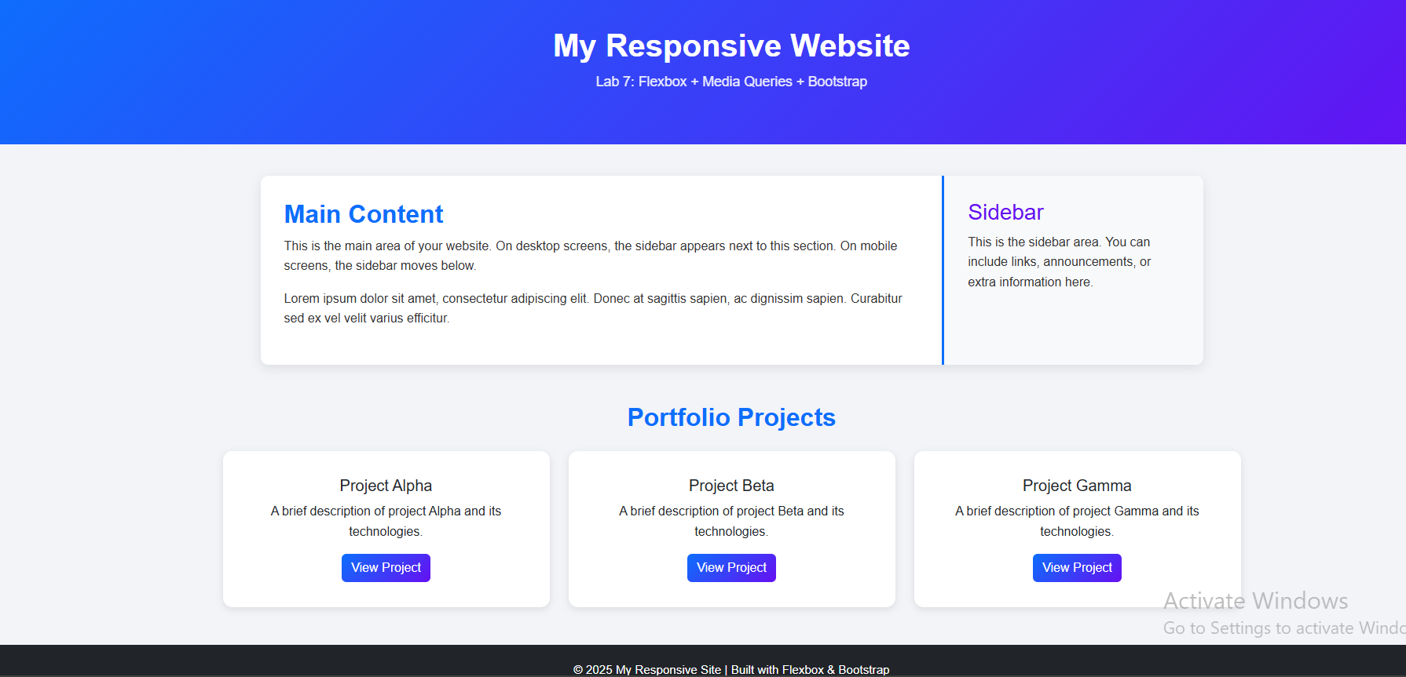
CONCLUSION:
________________________________________________________________________________________________________________________________________________________________________________________________________________________________

RUBRICS:

Performance |  |  | Lab Report
Description | Total Marks | Marks Obtained | Description | Total Marks | Marks  Obtained
Ability to Conduct practical | 5 |  | Structure | 5
Data Analysis & Interpretation | 5 |  | Efficiency | 5
Total Marks obtained |  |  | Total Marks Obtained

Instructor Signature

